Micro-Doppler Simulation of a Manoeuvre Quadcopter Using a Digital Array Radar
1. Introduction
Radar-based drone detection has gained significant importance due to the increasing use of unmanned aerial vehicles (UAVs) in civilian and military applications. Unlike conventional moving targets, quadcopters possess rapidly rotating propellers that generate unique micro-Doppler signatures, allowing them to be distinguished from birds, vehicles, or other airborne objects.
This project presents a MATLAB-based simulation of a manoeuvre quadcopter flying through predefined waypoints (A → B → C) observed by a 5 GHz digital array radar. The simulation models both the translational motion of the drone body and the rotational motion of the propeller blades. The received radar echoes are processed using matched filtering, digital beamforming, range-Doppler processing, and micro-Doppler analysis to demonstrate the radar's capability to detect, track, and characterize a manoeuvre drone.

2. Overview of the Main Simulation Code
The main MATLAB script (drone_microdoppler_digital_array_main.m) implements the complete radar signal processing chain, beginning from waveform generation and ending with visualization of the radar outputs.
The simulation follows these stages:
Step 1: Radar Initialization
The radar operating parameters are defined.
- Carrier frequency: 5 GHz
- Sampling frequency: 10 MHz
- Pulse Repetition Frequency (PRF): 20 kHz
- Linear Frequency Modulated (LFM) chirp waveform
- 4×4 Uniform Rectangular Array (URA)
The radar is assumed to be:
- stationary,
- non-scanning,
- operating in free-space,
- without atmospheric or wind effects.

Step 2: Drone Flight Path
Three waypoints are defined:
- A (Initial Position)
- B (Intermediate Waypoint)
- C (Final Position)
The drone flies
- A → B during the first 2 seconds
- B → C during the next 2 seconds
The drone velocity is updated automatically when waypoint B is reached.
if currentLeg == 1 && t >= cumT(2)
tgtmotion.Velocity = vel2;
end
This produces a manoeuvre target instead of a constant-velocity target.

Step 3: Drone Scatterer Generation
For every transmitted radar pulse, the script calls
droneMotion(...)
This function computes
- body position
- body velocity
- blade-tip positions
- blade-tip velocities
- look angle from radar
These scatterers are used as radar targets.

Step 4: Radar Echo Simulation
For every pulse,
- Generate LFM chirp.
- Transmit waveform.
- Propagate through free space.
- Reflect from drone body and blade tips.
- Collect echoes at every array element.
- Apply receiver noise.
Unlike the previous implementation, the received signals from all antenna elements are preserved individually.

Step 5: Digital Beamforming
Instead of simply summing all antenna channels,
sum(echo,2)
the simulation performs
beamformer(echo,scatterAng(:,1))
which applies delay-and-sum digital beamforming.
The beamformer updates its steering direction every pulse using the instantaneous target angle.
Advantages include
- coherent array gain,
- higher SNR,
- improved target detection,
- pulse-by-pulse adaptive steering.

Step 6: Pulse Compression
Matched filtering compresses the transmitted chirp into a narrow pulse to improve range resolution.
The matched filter output is
mfSignalRaw = mf(rxsig);

Step 7: Group Delay Compensation
Different MATLAB versions treat matched filter group delay differently.
Instead of using
'GroupDelaySource','Auto'
(which is unavailable in some toolbox versions), the simulation compensates manually.
groupDelay = length(mfcoeff)-1;

mfSignal(1:end-groupDelay,:) = ...
mfSignalRaw(groupDelay+1:end,:);
This shifts the matched-filter output upward by its known fixed delay so that every range bin corresponds to the true target distance.
No further changes are required because all subsequent processing uses the corrected signal.

Step 8: Target Tracking
The strongest range bin is selected every pulse.
[~,rangeBinTrack] = max(abs(mfSignal),[],1);
This allows the radar to follow the manoeuvre drone throughout the flight.

Step 9: Micro-Doppler Extraction
The signal from the tracked range bin is extracted
trackedSignal(m)=mfSignal(rangeBinTrack(m),m);
and converted into a spectrogram using
pspectrum(...)
to visualize blade-induced Doppler signatures.

Step 10: Range-Doppler Processing
Snapshots of the received signal are processed using
phased.RangeDopplerResponse
to generate Range-Doppler maps before and after the waypoint maneuver.

3. Drone Motion Function (droneMotion.m)
The droneMotion function models the physical motion of the quadcopter.
The drone is represented by
- one body scatterer
- eight blade-tip scatterers
for a total of
9 radar scatterers.

Body Motion
The drone body motion is generated using
phased.Platform
which updates
- body position
- body velocity
every radar pulse.
The body is assumed to move without rotation.

Rotor Geometry
Each rotor has
- radius = 0.12 m
- two blades
The four rotor hubs are positioned around the drone body using fixed offsets.

Blade Motion
For every rotor,
theta = bladeRate*t + bladePhase;
computes the instantaneous blade angle.
The blade-tip position becomes
tipPos = center + tipOffset;
while the blade-tip velocity is
tipVel = bodyVelocity + rotationalVelocity
where
tipVelRot =
rotorRadius*bladeRate*
[-sin(phi)
cos(phi)
0]
Thus every blade experiences
- translational motion
- rotational motion
simultaneously.

Radar Look Angles
Finally,
rangeangle(...)
computes the azimuth and elevation angles from the radar to every scatterer.
These look angles are used by the digital beamformer for pulse-by-pulse steering.

4. Algorithms Used
Processing Stage | Algorithm Used | Purpose
Waveform generation | Linear Frequency Modulated (LFM) chirp | Provides high range resolution after pulse compression
Pulse compression | Matched filtering | Compresses the transmitted chirp into a narrow pulse to improve range estimation
Group delay correction | Manual shift by length(mfcoeff)-1 samples | Removes the inherent matched-filter delay and aligns detected range with the true target range
Range processing | FFT-based range compression using phased.RangeDopplerResponse | Produces range profiles and Range-Doppler maps
Doppler processing | 128-point FFT across slow-time samples | Estimates target radial velocity
Micro-Doppler analysis | Short-Time Fourier Transform (STFT) using pspectrum(...,'spectrogram') | Extracts blade-induced Doppler signatures
Target range detection | Maximum-energy (argmax) range-bin detection | Tracks the strongest target return at every pulse
Drone motion | Piecewise constant-velocity model using phased.Platform | Simulates drone motion between waypoints with velocity updates
Digital array processing | Delay-and-sum digital beamforming (phased.PhaseShiftBeamformer) | Coherently combines all receive channels while steering toward the target each pulse

5. Simulation Results
5.1 Drone Range Track
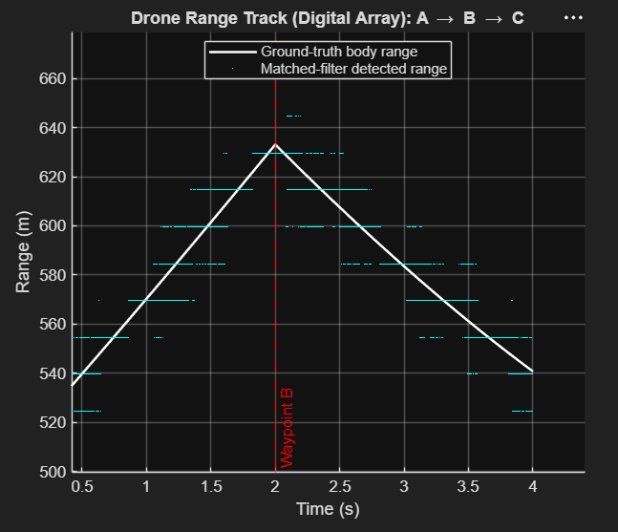
The range track compares the true drone range with the radar-estimated range.
The detected range closely overlaps the ground truth, demonstrating that
- matched filtering,
- manual group-delay compensation,
- and pulse-by-pulse range tracking
accurately follow the manoeuvre drone.
The change in slope at waypoint B corresponds to the change in flight direction.
Significance
- Validates accurate range estimation.
- Confirms successful target tracking throughout the maneuver.
- Demonstrates that the corrected matched filter removes range offsets.

5.2 Drone Radial Speed
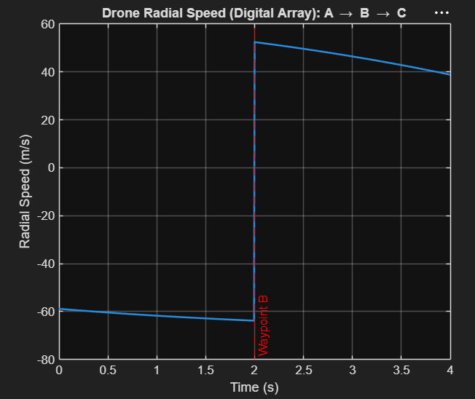
The radial speed plot shows the line-of-sight velocity of the drone.
During
- A → B
the radial velocity is approximately
−60 m/s
After waypoint B,
it changes to approximately
+50 m/s
because the drone changes its direction relative to the radar.
Significance
- Confirms correct implementation of the waypoint maneuver.
- Demonstrates that Doppler depends on the radial component of velocity.
- Explains the frequency shift observed in the micro-Doppler spectrogram.

5.3 Micro-Doppler Spectrogram
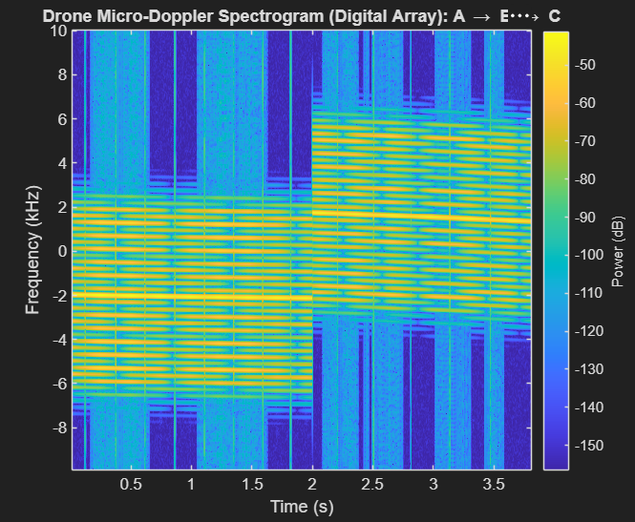
The spectrogram displays the Doppler frequency as a function of time.
The bright central band represents the Doppler shift produced by the drone body.
During
- A → B
the body Doppler is centered around
−2 kHz
After waypoint B (B → C),
it shifts to
+2 kHz
because the radial velocity changes sign.
The ladder-like structures surrounding the body Doppler are produced by the rotating blade tips.
These micro-Doppler sidebands arise because each blade alternately moves toward and away from the radar during every rotation.
Their spacing is determined by the blade-flash frequency, while the entire ladder shifts upward together with the body Doppler after the maneuver.
Significance
- Captures both translational and rotational motion simultaneously.
- Demonstrates successful extraction of micro-Doppler signatures.
- Provides unique features for drone identification and classification.

5.4 Range-Doppler Map (Mid-Leg A → B)
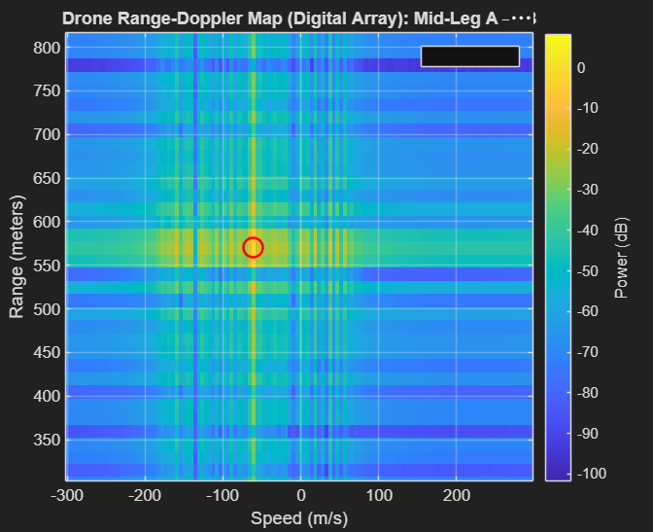
The first Range-Doppler map corresponds to the middle of the A → B flight segment.
The strongest reflection appears near
- Range ≈ 570 m
- Radial velocity ≈ −60 m/s
matching the simulated drone trajectory.
Significance
- Confirms accurate range and velocity estimation before the maneuver.
- Serves as a reference for comparison with the second flight segment.

5.5 Range-Doppler Map (Mid-Leg B → C)
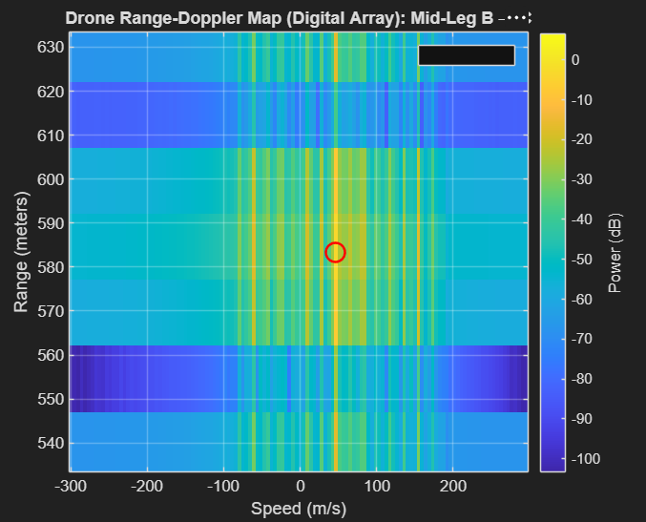
The second Range-Doppler map corresponds to the middle of the B → C flight segment.
The target is detected near
- Range ≈ 583 m
- Radial velocity ≈ +50 m/s
showing the expected change in Doppler after the waypoint.
Significance
- Demonstrates successful tracking after the drone changes direction.
- Validates the performance of the digital beamformer and Range-Doppler processing.

6. Conclusion
A complete simulation framework for a manoeuvre quadcopter observed by a digital array radar was successfully implemented. The radar processing chain integrates waveform generation, free-space propagation, digital beamforming, matched filtering, manual group-delay compensation, range tracking, Range-Doppler processing, and micro-Doppler analysis. The simulation accurately tracks the drone throughout its waypoint-based trajectory while simultaneously capturing the micro-Doppler signatures generated by the rotating propellers.
The results demonstrate that the digital array radar can reliably estimate target range and radial velocity while preserving detailed rotor-induced micro-Doppler information. The close agreement between the simulated ground truth and the radar-derived measurements validates the effectiveness of the implemented processing chain. Furthermore, the extracted micro-Doppler signatures provide distinctive features that are well suited for drone detection, tracking, recognition, and future machine learning-based classification, making this framework a realistic and extensible platform for advanced radar-based UAV research.

